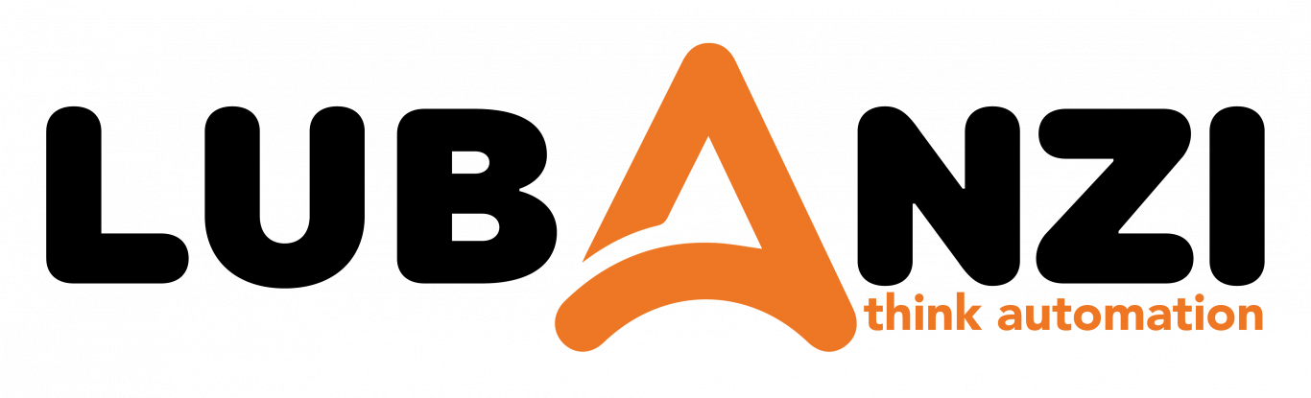

OrangeHRM Testing Project
System Exploration, Risk Assessment, and Test Preparation

Document ID | [DOC-0001]
Version | [1.0]
Date | [11 June 2026]
Prepared by | Team B: Nyeleti Maswanganye & Luthando Ndzendevu & Kamogelo Sekhaolelo
Approved by | Issac Mhlangu
Classification | Confidential

Introduction & System OverView

Introduction
This project sets up a clear plan for testing the OrangeHRM website. The website is an HR tool split into different sections (modules) like Logging In, the Dashboard, Employee Records (PIM), Leave, Time Tracking, Recruitment, Performance, Admin Control, and My Info.This document was prepared by Team B (Kamogelo Sekhaolelo, Luthando Ndzendevu, and Nyeleti) Maswanganye as part of Assignment 4

System Overview
OrangeHRM is a web-based Human Resource Management (HRM) system designed to help organizations manage employee information and HR processes. The system provides a centralized platform for HR administrators, managers, and employees to perform various human resource functions efficiently.
The overall system includes modules such as:
- Login / Authentication
- Dashboard
- PIM (Employee Management)
- Leave Management
- Time Tracking
- Recruitment
- Performance
- Admin Panel
- My Info

Through requirements discovery, the QA team will analyze these modules, identify key business workflows, understand user permissions, and document both functional and non-functional requirements to support comprehensive testing and quality assurance activities.

1.System Exploration Approach (Observation Phase)

- System accessed at: https://opensource-demo.orangehrmlive.com
- Login credentials used: Admin / admin123 (default demo credentials)
- Exploration conducted across two roles: Admin and ESS Employee
- Observations recorded per module covering: navigation paths, available actions, validation messages, and system responses
- Edge cases and unexpected behaviours were noted for inclusion in Section 8 (Risk Identification)

2. Functional Requirement Extraction
Login Module:
- The system allows users to log in using a valid username and password.
- The system validates user credentials before granting access to the system
- The system provides a "Forgot Password" feature for password recovery
- The system displays a error message for invalid credentials.
- Submitting empty fields produces inline validation messages below each field written "Required"
- Incorrect credentials produce an 'Invalid credentials' alert banner above the form.
- Successful login redirects immediately to the Dashboard.

Dashboard Module:
- The system displays a dashboard after successful login.
- The system displays employee and organizational information widgets.
- The system provides quick access to frequently used modules.
- The system displays announcements and notifications.
- The system allows users to view upcoming leave schedules and events.
- The system displays employee’s personal data.

PIM (Employee Management):
- The system allows authorized users to add new employee records.
- The system generates a unique employee ID for each employee.
- The system allows users to search employee records.
- The system allows users to view employee profiles.
- The system allows sediting of employee personal details.
- The system maintains employment history and job information.
- The system allows users to delete employee records where permitted.
- The system stores contact, emergency, and dependent information and employee documents.

Leave Management:
- The system allows employees to apply for leave.
- The system displays available leave balances.
- The system allows managers to approve or reject leave requests.
- The system notifies users of leave request status changes.
- The system maintains leave history records.
- The system allows administrators to configure leave types.
- The system prevents leave requests that exceed available balances.
- The system generates leave reports.

Time Tracking:
- The system allows employees to create timesheets.
- The system allows users to record working hours.
- The system allows users to submit completed timesheets.
- The system generates attendance and time reports.
- The system tracks employee work duration.

Recruitment:
- The system allows administrators to create job vacancies.
- The system stores candidate information.
- The system allows uploading candidate resumes, attempt to attach an unapproved file extension (e.g., an executable .exe file program) into the resume document field upload slot, the system will display validation message reading "File type not allowed" on screen.
- The system tracks candidate application status.
- The system allows scheduling interviews.
- The system records interview feedback.
- The system allows hiring managers to update candidate progress.
Performance:
- The system allow for the creation of performance reviews.
- The system allows managers to evaluate employee performance.
- The system allows employees to view performance evaluations.
- The system supports goal and KPI management.
- The system tracks review completion status.
- The system stores performance history.
- The system generates performance assessment reports.
- The system allows authorized users to update performance records.

Admin Panel:
- The system allows administrators to create user accounts.
- The system allows administrators to modify user account details.
- The system allows administrators to activate or deactivate user accounts.
- The system assigns system roles and permissions.
- The system configures job titles and employment statuses.
- The system configures leave, time, and system settings.
- The system rejects duplicate usernames with a clear error message.
- The system allows searching and filtering user accounts.

My Info:
- The system allows employees to view their personal information.
- The system allows employees to update personal details and emergency contacts
- The system allows employees to manage and update their contact information and dependent information.
- The system allows employees to upload personal documents.
- The system allows employees to view job and salary information based on permissions.
- The system allows employees to maintain qualifications and education records.
- Job, Salary, and Employment Status fields are read-only for ESS(Employee Self-Service) users.
- The system allows employees to view employment-related information

3. Non-Functional Requirement Identification
1. Performance Expectations (Assumed)
- The system should load dashboard pages within 3 seconds under normal operating conditions.
- User login should be completed within 5 seconds after valid credentials are submitted.
- Employee search results should be displayed within 2 seconds.
- The system must be strong enough for multiple workers (eg.500 workers) to log in and use it at the exact same time without the system slowing down or crashing.
- The system should efficiently handle large employee datasets.
- System response times should remain consistent during peak business hours

2. Security Considerations
- The system must require authentication before granting access to protected resources.
- Passwords must be stored securely using encryption or hashing mechanisms.
- The system must encrypt your data, block dangerous files (like viruses disguised as resumes), and automatically log you out if you walk away from your desk for 15 minutes.
- The system must enforce role-based access control (RBAC).
- Users must only access data authorized for their role.
- Sessions must expire automatically after a period of inactivity.
- The system must protect against unauthorized access attempts.
- Sensitive employee information must be transmitted securely using HTTPS.
- Personal employee information must be protected according to privacy and data protection standards.

3. Usability Expectations
- The user interface should be easy to navigate.
- Frequently used functions should be accessible within a minimal number of clicks.
- Forms should provide clear labels and instructions.
- Error messages should be meaningful and easy to understand.
- Success messages should clearly confirm completed actions.
- The system should maintain a consistent layout and design across modules.
- Users should be able to complete common HR tasks without extensive training.
- Search and filter functions should be easy to use.
- The application should provide responsive feedback to user actions.

4. Compatibility Expectations
- The system should support modern web browsers including:
  - Google Chrome
  - Mozilla Firefox
  - Microsoft Edge
  - Safari
- The system should function correctly on different screen resolutions.
- The application should be accessible on desktop and laptop devices.
- The system should support standard operating systems such as:
  - Windows
  - macOS
  - Linux
5. Reliability Assumptions
- The system should be available at least 99% of business operating hours.
- Employee records should be stored accurately without data loss.
- The system should maintain data integrity during updates and transactions.
- Failed transactions should not result in corrupted data.
- The application should recover gracefully from unexpected errors.
- Backup and recovery mechanisms should be available to restore critical data.
- User sessions should remain stable during normal usage.
- If the internet drops for just a few seconds, the website/system should try to freeze your screen and keep the text you typed safe, rather than deleting your work and making you type it all over again.

4.User Flow Mapping

1. Login → Dashboard Flow
This workflow maps the gateway path from the outer login page to the core user workspace.
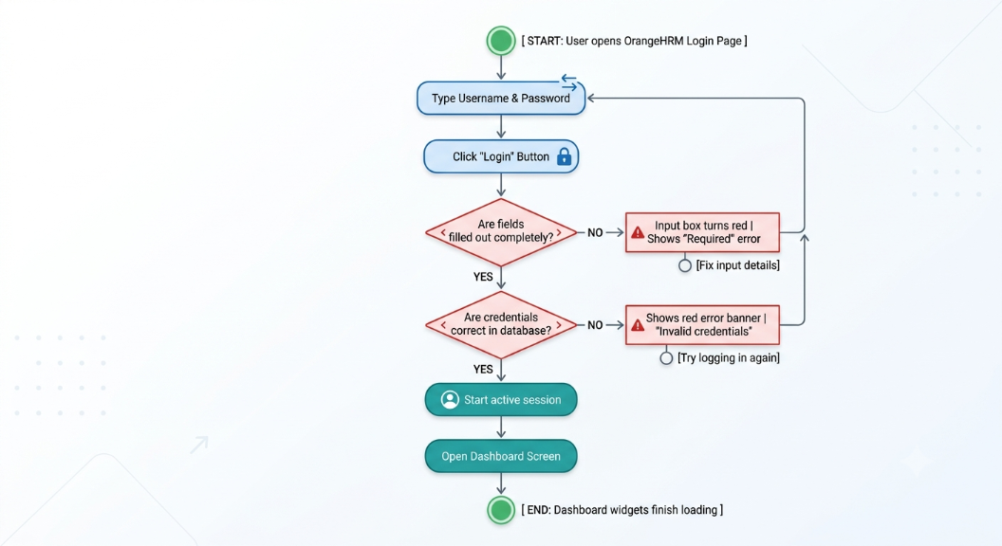

2. Employee Creation Flow (PIM Module)
This workflow outlines how HR personnel add a new worker profile to the central business registry database.
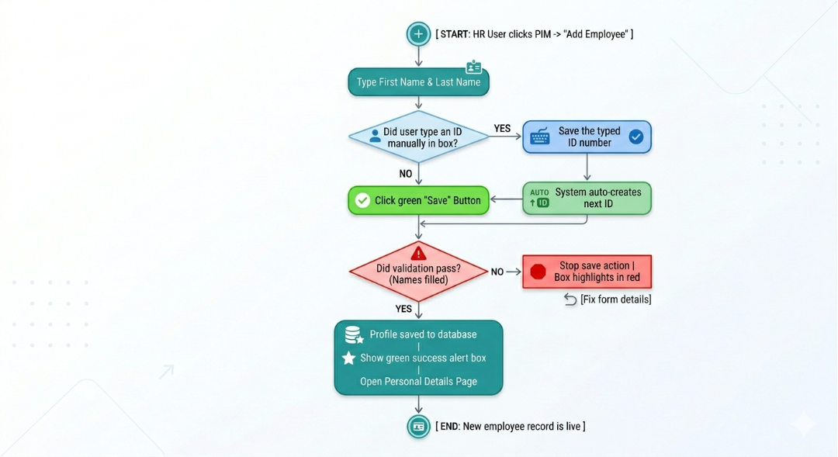

3. Leave Application Flow (Leave Module)
This workflow captures the multi-state cycle of a time-off submission from initial generation to final manager resolution.
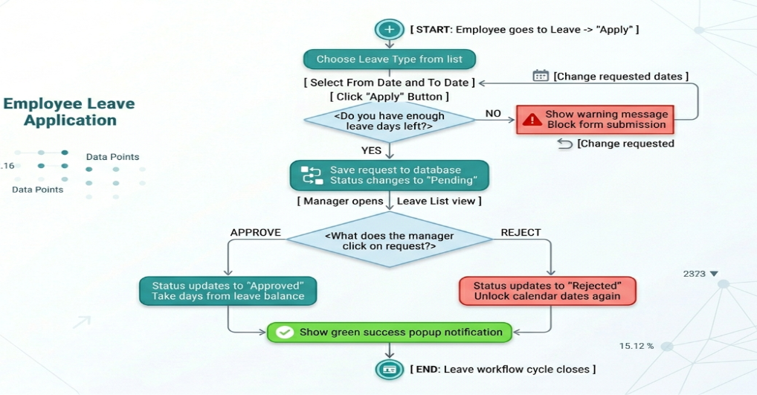

4. Recruitment Flow (Recruitment Module)
This workflow details the applicant tracking system roadmap, handling resume qualification and candidate status changes.
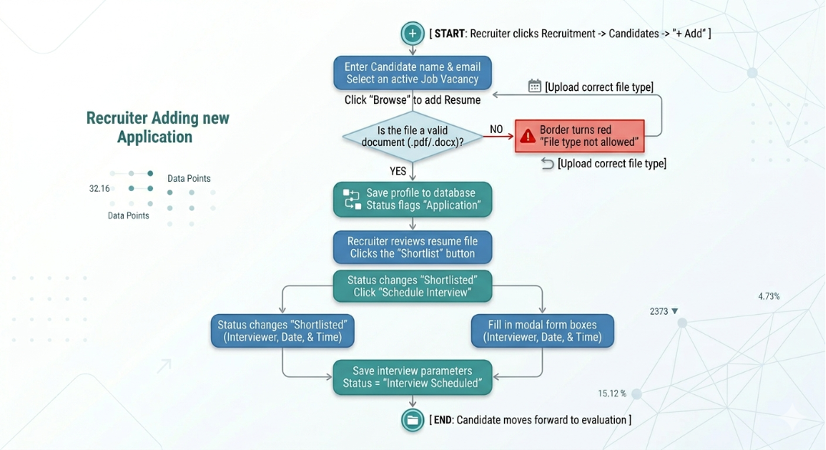

5. Requirement Categorization
- Functional Requirements (What it does): The basic buttons and features the website must have.
  - Example: The site must have a Login page, a Leave page, and an Employee List page.
- Non-Functional Requirements (How well it runs): The speed, safety, and reliability rules.
  - Example: Pages must load in under 2 seconds, and the site must stay alive if 500 workers use it at the same time.
- Business Rules (The company laws): The strict logic constraints that control how company data behaves.
  - Example: You are blocked from asking for 10 vacation days if your balance only shows 5 days left.
- Validation Rules (The data checks): The gatekeepers that block bad or missing info.
  - Example: The system must stop you if you leave your password blank, or if you try to upload a virus instead of a resume file.
- UI Expectations (What it looks like): The visual signs that show the user what is happening on screen.
  - Example: Empty boxes must turn red, successful saves must pop up a green alert box for 3 to 5 seconds, and locked fields must be greyed out.

6. Requirement Prioritization

Priority Level Definitions
- High (Critical/Must-Have): The system's foundation. If these fail, the platform is unusable, and core business operations stop completely.
- Medium (Important/Should-Have): Essential operational tools. If these fail, the core system still works, but users face significant inconvenience and must rely on manual workarounds.
- Low (Nice-to-Have/Could-Have): Aesthetics and convenience. These features improve user experience or offer extra insights; the system remains fully functional without them

Module | Requirement | Priority | Reason
Login/Authentication | User login and access control | High | Primary gateway; system is unusable without it. Users cannot access the system without authentication.
PIM (Employee Mgmt) | Add/edit/view employee records & IDs | High | Employee data management is a core HR function.
Time Tracking | Clocking in/out and timesheet submission | High | Essential for daily operations and payroll accuracy.
Admin Panel | System stability/Power outage protection | High | Ensures data integrity during infrastructure failure.
Leave Management | Requesting and approving leave | Medium | Important for daily tracking; manual alternatives exist.
Recruitment | Interview scheduling, feedback, & file scanning | Medium | Enhances process, but hiring can proceed manually.
Performance | Performance reviews and KPI tracking | Medium | Important for development, not daily operations.
My Info | Viewing/updating personal details | Medium | Important for employee self-service.
Dashboard | Home screen widgets and summary charts | Low | Convenience feature for productivity.
System-wide | UI styling, fonts, and notification popups | Low | Cosmetic/Nice-to-have; does not impact functionality.

7. Risk Identification
7.1 Functional Risks
Risks arising from system functions that may not behave as expected.
Risk ID | Category | Description | Impact | Suggested Mitigation
RISK-F-01 | Functional | Weak login security | Unauthorized system access | Implement account lockout after 5 consecutive failed attempts; add CAPTCHA for web access
RISK-F-02 | Functional | Missing punch sequence logic | Corrupted attendance records | Enforce Punch-In before Punch-Out
RISK-F-03 | Functional | Unrestricted back-dated leave | Unreliable audit trails | Add date validation checks
RISK-F-04 | Functional | Overwriting approved timesheets | Payroll discrepancies | Lock 'Approved' status records
RISK-F-05 | Functional | No confirmation for status changes | Recruitment history corruption | Add confirmation prompts & logs

7.2 Data Risks
Risks related to data integrity, loss, or corruption.
Risk ID | Category | Description | Impact | Suggested Mitigation
RISK-D-01 | Data | Deletion of employees with active records | Orphaned data breaks reporting | Implement pre-delete checks/warnings
RISK-D-02 | Data | Lack of ID uniqueness enforcement | Database corruption | Enforce unique IDs at database level
RISK-D-03 | Data | Unsaved data loss during timeout | Loss of user work/progress | Auto-save drafts and session alerts expire
RISK-D-04 | Data | Invalid date of birth entries | Poor data quality/calculation errors | Add date-range validation logic

7.3 Security Risks
Risks related to unauthorised access, data exposure, or system compromise.
Risk ID | Category | Description | Impact | Suggested Mitigation
RISK-S-01 | Security | No password strength enforcement | Weak passwords | Enforce a password policy: minimum 8 characters, at least one uppercase, one number, and one special character
RISK-S-02 | Security | Unclear session token handling | Concurrent access for single accounts | Invalidate older sessions on new login
RISK-S-03 | Security | Potential API/URL privilege escalation | Exposure of unauthorized data | Implement role-based API access controls
RISK-S-04 | Security | Absence of multi-factor authentication | Vulnerability to phishing/stuffing | Require MFA for admins and all users
7. 4 Workflow Risks
Risks arising from gaps or ambiguities in business process flows.
Risk ID | Category | Description | Impact | Suggested Mitigation
RISK-W-01 | Workflow | Manager can self-approve leave | Compliance and control failure | Enforce separate approver requirements
RISK-W-02 | Workflow | Race conditions during dual approval | Data inconsistency / balance errors | Implement locking/status verification
RISK-W-03 | Workflow | Vacancy status fails to auto-close | Unintended over-hiring | Auto-close vacancy on position capacity
RISK-W-04 | Workflow | Pending approvals for deactivated users | Approvals stuck in "limbo" | The system should reassign or flag pending approvals when a user is deactivated; admin should be notified

7.5 Missing Requirement Risks
Requirements that are likely needed but could not be confirmed from the demo environment.
Risk ID | Category | Description | Impact | Suggested Mitigation
RISK-M-01 | Missing Req. | Lack of email notification system | Operational delays in approvals/updates | Verify/implement notification module
RISK-M-02 | Missing Req. | Absence of audit trails | Inability to track changes or ensure accountability | Implement comprehensive activity logging
RISK-M-03 | Missing Req. | Undefined data retention/archiving | Potential labour law non-compliance | Implement archive policy over hard-deletion
RISK-M-04 | Missing Req. | Unverified password reset flow | Increased support overhead for lockouts | Perform end-to-end testing in production-like environment

8. RTM (Requirements Traceability Matrix (RTM ) Draft
Requirement ID | Module | Description | Testable Condition
FR-LOG-01 | Login | User logs in with valid credentials | User successfully accesses dashboard
FR-LOG-02 | Login | Invalid credentials rejected | Error message displayed
FR-DB-01 | Dashboard | Dashboard displayed after login | Dashboard loads successfully
FR-PIM-01 | PIM | Add employee record | Employee record saved successfully
FR-PIM-02 | PIM | Search employee | Employee appears in search results
FR-LVE-01 | Leave | Submit leave request | Leave request created
FR-LVE-02 | Leave | Approve leave request | Leave status changes to Approved
FR-TT-01 | Time Tracking | Create timesheet | Timesheet saved successfully
FR-TIT-02 | Time Tracking | Submit timesheet | Timesheet status changes to Submitted
FR-REC-01 | Recruitment | Create vacancy | Vacancy appears in vacancy list
FR-REC-02 | Recruitment | Add candidate | Candidate record saved
FR-PER-01 | Performance | Create performance review | Review successfully created
FR-AD-01 | Admin | Create user account | User account available for login
FR-AD-02 | Admin | Assign user role | User receives assigned permissions
FR-MYF-01 | My Info | Update personal information | Updated information saved successfully

9. Assumptions Document
A. Assumptions Made During Analysis
- The OrangeHRM Demo System reflects typical HR management business processes.
- The demo environment contains representative functionality of the production system.
B. System Behavior Assumptions (How the platform acts):
- Users must authenticate before accessing protected modules.
- The system automatically validates mandatory fields before saving records.
- Successful transactions generate confirmation messages.
- Failed transactions generate error messages
C. Business Logic Assumptions (The company rules):
- Each employee has a unique Employee ID.
- Leave requests require approval before becoming effective.
- Leave balances are automatically updated after approval.
- Timesheets must be submitted before manager approval.

NOTE Use this callout style to draw attention to important information, warnings, or reminders within the document body.

